**Lab no 4**

**RMI CALLBACK:**

**Task:** Develop the RMI Callback application of Payroll and PayrollMessage services for calculating the earnings.

**Interface:**

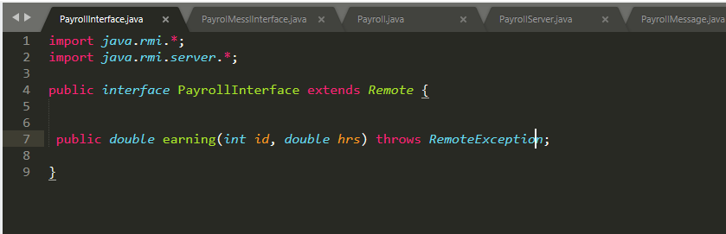

**MessageInterface:**

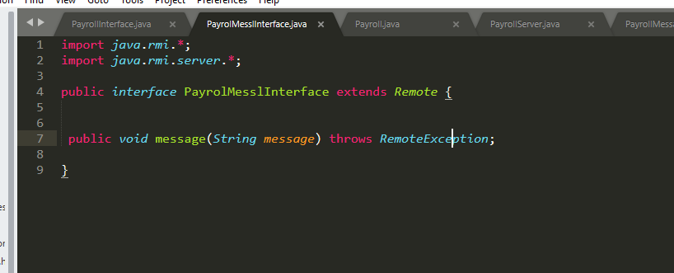

**Payroll:**

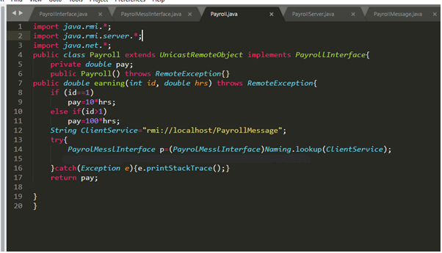

**PayrollServer:**

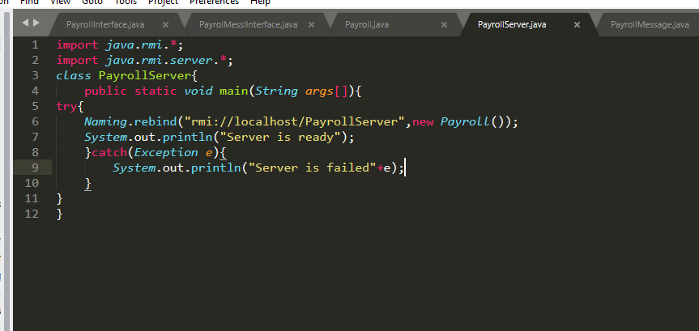

**PayrollMessage:**

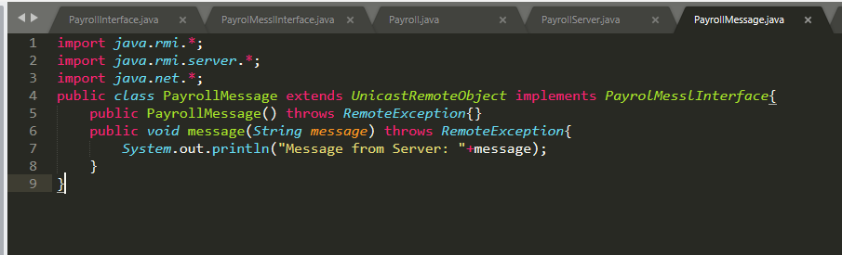

**PayrollMessageServer:**

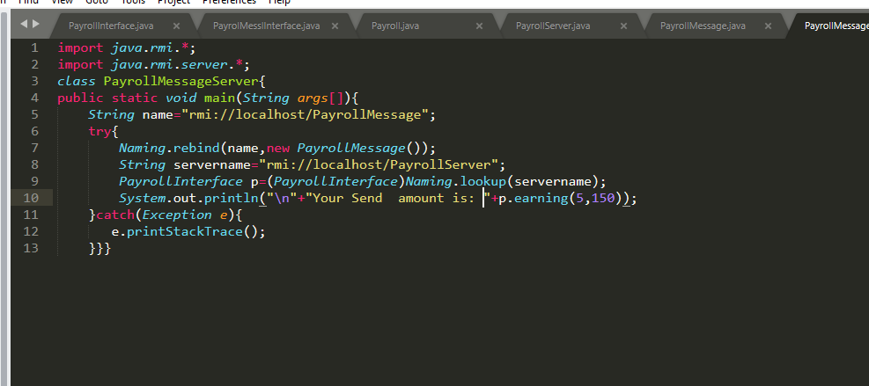

**Output:**

